GNSS and Correction Troubleshooting
GNSS Diagnostics

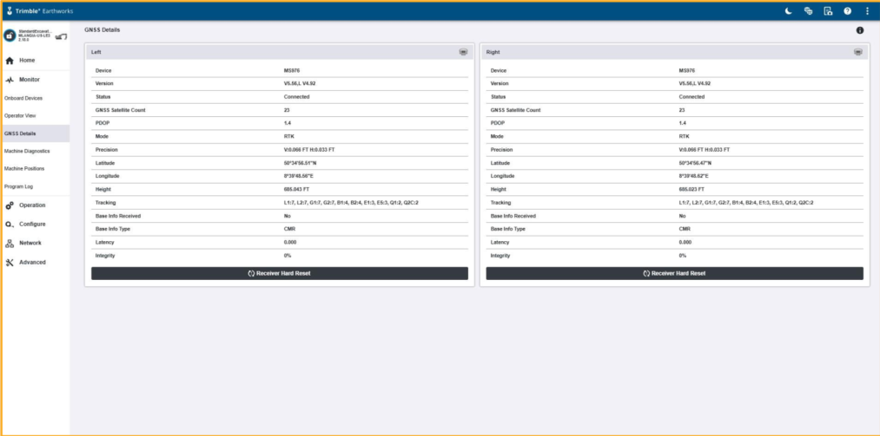
Receiver Blink Codes
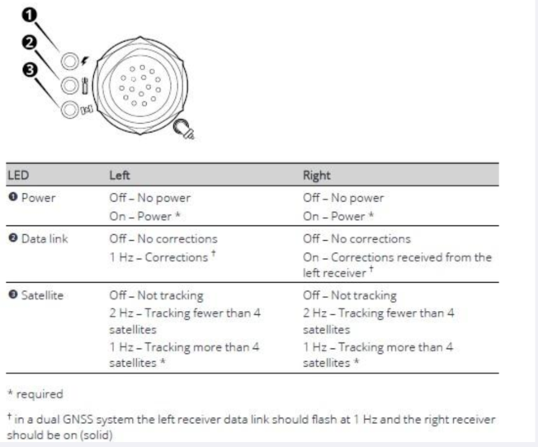
SNRX34 Radio Blink Codes
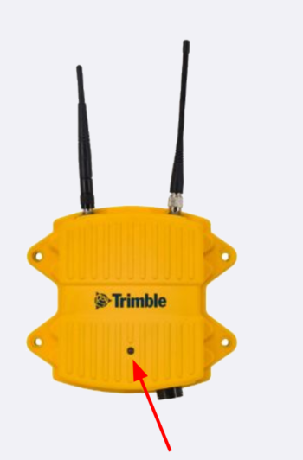
SNRx34 Multi–band Radio Modem:
Receives GNSS corrections from the base:
LED indicator on solid - receiving data but not yet synchronized. Also, when first turned on.
LED indicator flashing steadily - receiving data and synchronized with the radio at the base.

